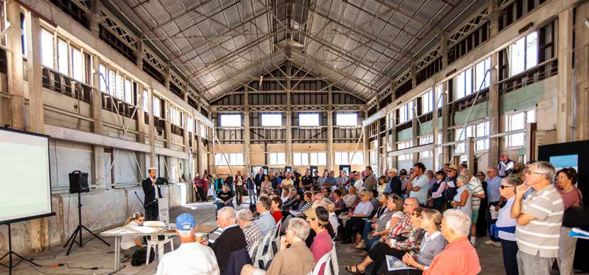
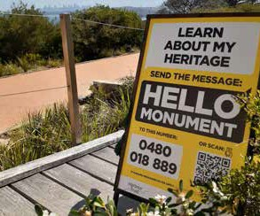
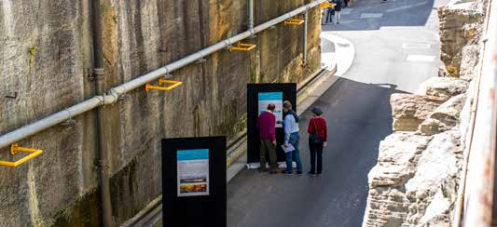
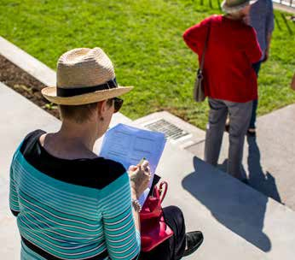
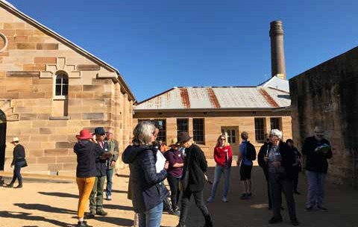

DRAFT
STAKEHOLDER ENGAGEMENT STRATEGY & GOVERNANCE FRAMEWORK

CONTENTS

Foreword 3

Sydney Harbour Federation Trust Independent Review 4

recommendations and actions

Executive summary 5

- Our engagement model 6
- Why we consult 7
- What we consult about 8
- Who we consult 9
  - Deeper engagement with community 10
  - Co-ordination with governments 11
  - Proactive outreach to business community 11
  - Input from expert advisers 11
  - Stakeholder Groups 12
- How we consult 13
  - Consultation process for planning decisions 15
  - Consultation process for other matters 17
  - Trust Members interaction with stakeholders 19
  - Management interaction with stakeholders 19
- Governance 20
  - Community Advisory Committee governance 20
  - Aboriginal and Torres Strait Islander Advisory Group governance 23
  - Government Forum governance 25

- FOREWORD

The places managed by the Sydney Harbour Federation Trust are internationally significant and have extraordinary value to residents, metropolitan Sydney and the nation.
Standing at the entrance to Sydney Harbour and straddling its foreshore, they are places of striking natural beauty. They are First Nations countries and became sites of the first European settlement on the continent. They contain places of historic and contemporary importance to the military and veterans of war. They provide residents of Australia’s largest city with precious bushland, parks and open spaces. They preserve rich examples of maritime and industrial heritage.
These places have a multifaceted character. While they have value to international tourists, to metropolitan Sydney and the nation, they are also local neighbourhoods valued by residents. While they must meet the needs of contemporary users, they also must be managed for the benefit of future generations.
This diversity of interests must be reflected in the reasons why we consult stakeholders, what we consult about, who we consult and how we consult.
As the Harbour Trust evolves to an ongoing entity and embarks on important new projects funded by the Commonwealth, we are presented with an opportunity
to consult about a broader range of subjects and engage a wider set of stakeholders.
This Stakeholder Engagement Strategy & Governance Framework expands the subjects about which we will consult, extends the set of stakeholders with whom we engage, and provides a clear explanation of how we will collect feedback and incorporate it in our decisions.
It is an essential element in our vision to create extraordinary places on the world’s best harbour that are inspiring, loved and shared.

Joseph Carrozzi Chair
Mary Darwell
Chief Executive Officer

SYDNEY HARBOUR FEDERATION TRUST INDEPENDENT REVIEW RECOMMENDATIONS AND ACTIONS

Table 1: Independent Review recommendations and actions

RECOMMENDATION ACTIONS

  - Community involvement in the work of the Harbour Trust should be strengthened by:

    - Greater use of Technical Advisory Committees to supplement the expertise of the Harbour Trust when dealing with complex tasks or issues.

    - Reconstituting and refocusing the Community Advisory Committees as consultative forums so that they are more directly involved in priority-setting by the Harbour Trust. This should include the attendance of at least one Harbour Trust Board member at each meeting.

    - Establishing a dedicated annual budget for community, volunteer and Aboriginal and Torres Strait Islander projects aimed at increasing site visitation, enhancing the visitor experience or improving public access.

    - More active engagement by the Harbour Trust Board and management with volunteers, community groups and others at a site-by-site level.

10. The Harbour Trust should consult appropriately and facilitate a more joined up approach to the management of contiguous public lands and facilities held by neighbouring Local Councils and explore opportunities for additional collaboration, such as a joint calendar of community events on Harbour Trust sites.

The Harbour Trust will engage technical experts to advise, and convene as required technical committees to deal with complex tasks or issues. See page 12.
The Community Advisory Committee is to be reformulated and it’s work supplemented by “always on” consultation. Governance arrangements are to be refreshed to ensure the best use of members time and skills.
Trust members attendance to Committee is encouraged.

Not covered by this strategy, to be considered as part of organisational reform.

Increased visibility and involvement of Harbour Trust members and management will be achieved through this strategy.
See page 19.

The Harbour Trust will establish a formal Government stakeholder group, to be supplemented by always on engagement and a greater focus on enhancing visitor experiences. See page 11.

14. The Harbour Trust should establish a partnership with the Environment and Engineering Branch in the Estate and Infrastructure Group of the Department of Defence, to support the interpretation of the Harbour Trust sites in respect of their military history.

The Harbour Trust will establish a formal Government stakeholder group and is in discussion to establish a formal partnership.

EXECUTIVE SUMMARY
The Sydney Harbour Federation Trust has accountability to consult widely and act transparently. This is because we are stewards of a public resource owned by all Australians and we act as both land manager and consent authority.
We are committed to collaboration because we know it helps generate great ideas and produces benefits for stakeholders and the Harbour Trust. We are committed to interacting with stakeholders in ways that are guided by our values.
Some of our most significant consultations are those relating to planning and land use decisions. But even where formal planning and land use decisions are not required, we would like to know more about our stakeholders’ aspirations, concerns, experiences and needs, so that these can shape our work.
The Harbour Trust routinely engages with more than 50 public sector bodies, more than 100 other organisations and community advisory committees.
As we evolve to a permanent entity and initiate important new projects, we will implement a series of initiatives designed to increase and broaden our engagement with stakeholders.
We will increase our community engagement generally, consult directly with communities of interest to inform them or obtain inputs about specific places and themes, and reconstitute our Community Advisory Committee to represent a broader cross section of the community. Additionally, we will create a new Government Forum, improve our engagement with business and greater use of expert advisers as a supplement to in-house knowledge.
These actions will reduce barriers to participation, broaden the range of stakeholders with whom we engage, provide a balanced set of feedback from passive as well as energetic stakeholders and provide new ways for business, government and experts to engage with us. The result will be deeper engagement with the community and a better balance between input from the community and from other contributors.
At a minimum, the format of our consultations will always meet the requirements of our plans, policies and relevant laws. Independently of this, however, we
will structure our consultations so they occur as early as possible, are properly planned and resourced, involve as many voices as possible, incorporate feedback from stakeholders, enable timely decisions and provide feedback to contributors.

OUR
ENGAGEMENT MODEL

Table 2: Our engagement model
BACKGROUND
(Why we consult and what we consult about)

OUR STAKEHOLDERS
(Who we consult — Table 3)

OUR ENGAGEMENT PRINCIPLES
(How we consult — Table 6)

OUR ENGAGEMENT PROCESSES
Organised by stakeholder group (Table 4) Organised by decision type (Tables 7, 8 and 9)

WHY WE CONSULT
We have accountability to consult widely and act transparently because we are stewards of a public resource owned by all Australians, and because we act as both land manager and consent authority.
More fundamentally, we understand that collaboration generates great ideas. The more diversity the better. By bringing together experts, the community, business interests and governments, and by making engagement meaningful and purposeful, outcomes will always be better than they would be if developed by the Harbour Trust in isolation.
Engagement produces benefits for stakeholders and the Harbour Trust. It drives awareness of our sites, improves community, helps us understand stakeholders’ needs, builds consensus, enhances our relationships, improves transparency and can avoid wasted time and resources.

WHAT WE
CONSULT ABOUT
Some of our most significant consultations relate to significant new policies that reach across all our sites and activities, as well as planning and land use decisions.
This includes changes to our Comprehensive Plan, new or amended Management Plans and Supporting Policies and certain Proposed Actions (also commonly understood as ‘Development Applications’ or ‘DAs’). Examples are provided later in this strategy.
Importantly, however, we aim to expand the matters that we consult about. Even if planning decisions may not be required, we will consult on priorities for precinct planning and explore what stakeholders think about the places we manage and how they are managed.
For instance, we will ask —
- Community members about their experience as a visitor, residents about their aspirations, advocacy groups about their concerns, volunteers about their experience, people with disability about their needs and Aboriginal and Torres Strait IslanderAustralians, environmentalists around our bush care and landscape management, active sporting groups about use of existing facilities, historians and veterans about the interpretation or activation of sites,
- Governments about how their services — and our own decisions — can be better co-ordinated to benefit the community;
- Businesses including tenants, event producers, peak bodies and business chambers, for advice about how to bring economic activity and investment, draw tourists and attract philanthropic partners; and
- Experts for inputs and advice about relevant subjects to supplement
in-house knowledge and contributions of other stakeholders, including cultural and arts institutions around programing.

WHO WE CONSULT
In all, the Harbour Trust routinely engages with more than 50 public sector bodies and more than 100 organisations and interests across business, government and the community. We think of these groups as belonging to broad categories that include ‘government’, ‘expert’, ‘business’ and ‘community’ as follows:
As we evolve to a permanent entity and initiate important new projects, we will implement six initiatives to deepen, broaden and balance our engagement with stakeholders. These actions will provide more and new ways for the community, governments, business and experts to engage with us. The result will be more meaningful and satisfying engagement, opportunities for new stakeholders to provide input, and better balance between the influence of energetic and passive stakeholders.

Table 3: Primary Harbour Trust stakeholders

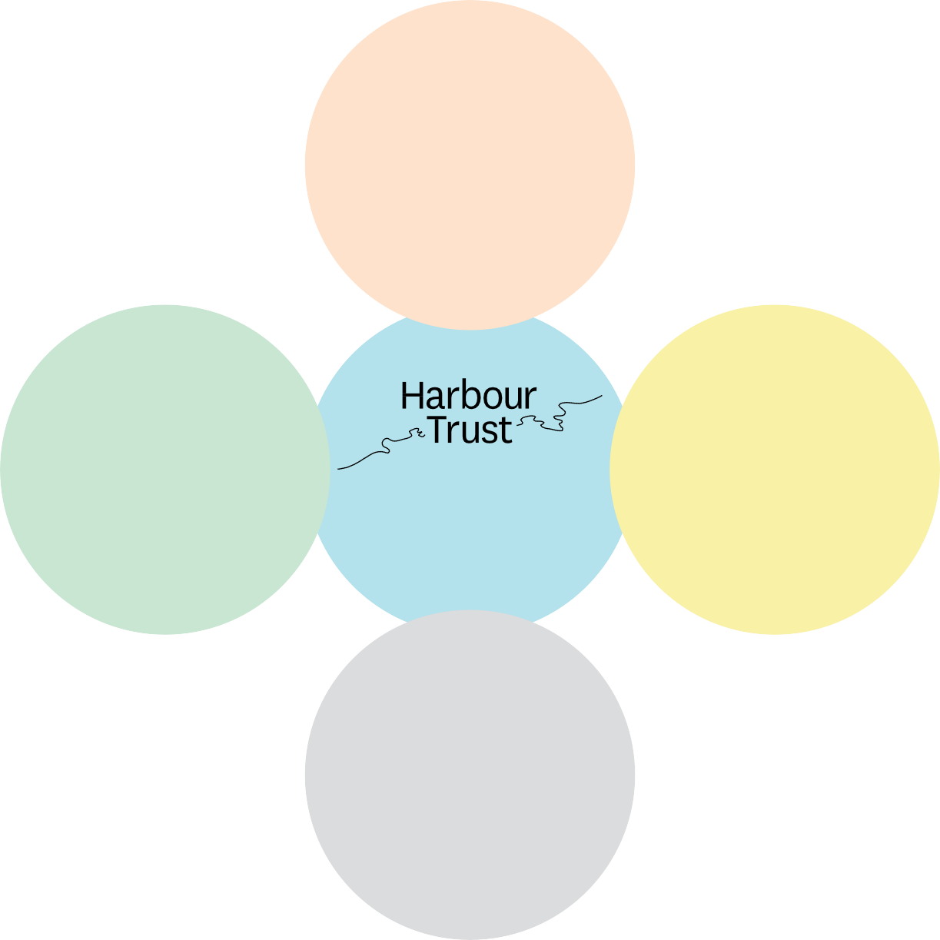
GOVERNMENTS
- Commonwealth, including veterans services and defence
- New South Wales
- Local governments
- Utilities
- Emergency services

COMMUNITY
- Residents
- Greater Sydney and beyond
- Cultural and Linguistically diverse communities
- Local Aboriginal and/or Torres Strait Islander communities
- Local interests (eg veterans)
- Advocacy groups
- People with disabilities
- Prospective users
- Sporting clubs

- Members of the Trust
  - Leaders and staff
    - Volunteers
- Guides

EXPERTS
  - Environmental scientist
  - Traditional custodians
    - Heritage advisors
- Architects
    - Military Historians
- Cultural and arts institutions

BUSINESS
  - Tenants
- Event producers
- Business chambers
- Peak bodies
- Prospective users

Deeper engagement with the community

INITIATIVE ONE
First, we will do more to drive general awareness, attract visitors and increase opportunities for feedback. This will take the form of always-on, opportunistic engagement with visitors, and initiatives to build general awareness using earned, owned and paid media channels. Subjects may include visitor experience, service and infrastructure quality and information about events or activations.

INITIATIVE TWO
Second, where it is a statutory requirement, or is warranted by community interest, we will engage with stakeholders from a specific location or community-of-interest.
Typically, our purpose will be to inform the community or obtain feedback about a particular idea, concept or public exhibition specific to a site or subject. We will primarily target stakeholders we know to be interested, but we will often reach beyond these groups to ensure we hear from a representative set of stakeholders. To reduce barriers to participation, we will emphasise digital and informal forms of engagement. Our consultation with the community about Sub Base Platypus in North Sydney will transition to this format as stage two of construction concludes.

INITIATIVE THREE
Third, in 2021 the Community Advisory Committee (CAC) will be reconstituted with a new remit and broader membership. The CAC will continue to provide input on ideas, concepts and public exhibitions in all the places we manage. Additionally, through advocacy in their own communities, CAC members will act as a force multiplier, helping us to build awareness and drive engagement from a more diverse set of stakeholders in priority communities. Members of the reconstituted CAC will be selected based on their capacity to represent a Harbour Trust place, residents
of Greater Sydney, education guides and site volunteers, military veterans, local Aboriginal and Torres Strait Islander communities, culturally and linguistically diverse (CALD) communities; users with disabilities and those with specific interests relevant to our sites. We will especially welcome members who bring professional experience in stakeholder engagement because they will help us continuously improve our practice.
Our Aboriginal and Torres Strait Islander Advisory Group will commence meeting quarterly, up from half-yearly, to provide more opportunities for us to interact with this key constituency.
Improved governance arrangements will improve two way engagement with both committees.
Together, these initiatives will drive community awareness, increase visits, provide more feedback, amplify our message and make consultations more relevant.
This will give more stakeholders a voice and provide us with a better representation of community opinion.

Co-ordination with governments

INITIATIVE FOUR
Fourth, a new ‘Government Forum’ will be established to enable us to interact with officials and elected office holders from all levels of government. This will enable officials and politicians to provide input about planning and investment decisions and co-ordinate the services and support they each provide.
Members will include relevant members of Commonwealth and New South Wales parliaments, representatives of Commonwealth and New South Wales government departments and agencies such as the National Parks and Wildlife Service, as well as local government mayors and general managers.

Proactive outreach to the business
community

INITIATIVE FIVE

Fifth, we will increase our engagement with the business community.
Sympathetic commerciality is important to the Harbour Trust and will have
a positive impact on the community and precincts that we create. It will build business confidence, attract private investment, drive economic activity and increase visitor numbers.
We will do this by increasing our participation in established business networks such as local business chambers and peak bodies representing key sectors such as tourism and transport and though greater cross-promotion of our sites with other cultural and recreational institutions.

Input from expert advisers

INITIATIVE SIX
Sixth, we will engage with subject matter experts to obtain inputs and advice to supplement in-house knowledge and the contributions of other stakeholders. This may include sourcing advice from professional firms, government departments or cultural institutions on subjects as the environment, climate science, decontamination, heritage, architecture, history and natural hazard management. Where complex task and issues warrant, technical committees may be used.

Table 4: Stakeholder objectives and formats

COMMUNITY | GOVERNMENT | BUSINESS

Who
EXPERTS/ ADVISORS
Everyone People interested in
a specific place or theme
Priority communities*
Aboriginal and Torres Strait Islander Australians
Politicians and officials
Business community
Subject matter experts

Objective

Example topics
Drive awareness; attract visitors; obtain feedback from more people

General information about and invitation to visit; service quality and visitor experience; public exhibitions; events and activations
Inform and obtain input about specific matters from people interested in
a place or theme, including heritage, environmental and military perspectives

Specific ideas, concepts or public exhibitions about a place or theme
Inform and obtain input about specific matters; form partnerships that drive awareness and amplify our voice

Specific ideas, concepts or public exhibitions about all places and themes; initiatives that grow awareness and engagement
Inform Harbour Trust work on cultural competence; drive Reconciliation Action Plan; inform and obtain input from Aboriginal and Torres Strait Islander leaders and communities
Cultural competence of Harbour Trust; content and execution of RAP; Aboriginal and Torres Strait Islander perspective on ideas, concepts or plans;
Co-ordinate, inform and obtain feedback from politicians, governments and agencies

Integration of decisions, allocation of resources; co-ordination of services
Co-ordinate, inform and obtain feedback from business; form partnerships that engage relevant sectors

Stimulation of awareness and economic activity; extending interaction with key sectors
Obtain inputs and advice to supplement in-house knowledge and contributions of others on complex tasks and issues

Specific ideas, concepts or public exhibitions about all places and themes

How was your visit? How should we activate
this place?
What does your community think about this?
What do the Aboriginal and Torres Strait Islander communities want the Harbour Trust to focus on
How can decisions be integrated for the public good?
How can we stimulate activity and engage the visitor economy?
How can your knowledge inform our response to this issue?

Format
Always-on visitor engagement and earned, owned and paid media channels
Episodic engagements, mainly via digital formats
Community Advisory Committee
Aboriginal & Torres Strait Islander Advisory Group
Government Forum
Proactive outreach to and integration with users, peak bodies, business chambers
Request for technical advice or where warranted a technical committee

Frequency Continuous As required Quarterly Quarterly Half-yearly Continuously Per needs basis

What’s new?
Additional engagement
Additional engagement
CAC to be reconstituted and broadened in 2021
Meeting frequency to increase from
half-yearly to quarterly
New Government Forum to be constituted in 2021
Expanded program of partnerships and memberships
Additional engagement

12

*Priority communities include local residents, residents of Greater Sydney, guides and volunteers, military veterans, users with disabilities, culturally and linguistically diverse (CALD) communities.

HOW WE CONSULT
This section outlines how this Stakeholder Engagement Strategy & Governance Framework will be applied when we conduct consultations.
Generally, our consultation process will include the following steps.

Define level
of participation based on
consequence

Provide feedback and reasons

Table 5: Harbour Trust consultation cycle

Define purpose,
objectives, resources

Determine appropriate engagement
methods

Identify affected stakeholders

We interact with stakeholders in accordance with the Sydney Harbour Federation Trust Act, The Comprehensive Plan, Corporate Plan and Reconciliation Action Plan — which sets out our values, as follows:

Table 6: Engagement principles
OUR VALUES WHAT IT MEANS HOW IT WILL BE EXPRESSED

We are open

We are accountable

We are collaborative

We are entrepreneurial

We are creative

We act with integrity

We will be transparent with stakeholders

We will act responsibly and explain our decisions

We will involve everyone and value their inputs

We will vary approaches to involve more people

We will be creative to help everyone have a say

We will make principled decisions
- We will explain in advance how and when we will consult
- We will communicate frequently and purposefully
- Our documents will be accessible, easy to understand and made public where possible

- We will consult before key decisions are made
- We will explain the reasons for our decisions
- We will explain how we considered stakeholders’ input
- We will consult in a spirit of partnership
- We will consult as early as possible in the process
- We will provide information to help stakeholders understand
- We will identify and remove barriers to participation
- We will seek to involve all perspectives
- We will ensure all voices are heard

- We will work flexibly
- We will vary processes and methods to broaden engagement and hear from diverse voices

- We will let stakeholders contribute in ways that suit them
- We will innovate in how we consult
- We will make it easy for stakeholders to have input

- We will treat stakeholders fairly
- We will give weight to informed and authoritative voices
- We will be honest with stakeholders

Consultation process for planning decisions
Our Comprehensive Plan requires us to consult in particular ways that are outlined in Section 11 of the Comprehensive Plan. This requires us to exhibit draft Management Plans, draft supporting policies, and certain Proposed Actions.
The Comprehensive Plan sets out the rules for notification, inviting public submissions and consulting a defined set of stakeholders. We will always meet these requirements.
The following table sets out the minimum consultation requirements that apply when we make statutory decisions. Example flow charts that illustrate the consultation process are contained on pages 180, 183 and 187 of our Comprehensive Plan.

Table 7: Consultation process for planning decisions

DECISION DESCRIPTION STATUTORY
TRIGGER

INTERESTED PARTIES

ENGAGEMENT REQUIRED BY LAW OR REGULATION

ADDITIONAL MODES WE MAY USE

DECISION MAKERS

Where we propose changes to the Comprehensive Plan
Where we propose or amend a Management Plan

Where we propose or change key Policies

Where we assess Proposed Actions
Where we propose changes to the Plan that sets our vision for all sites and provides
a framework for use

Where we propose or change a Plan that sets out detailed information about particular matters or places

Where we propose
or change key Policies that contain detailed principles and procedures for specific matters
(eg. Leasing Policy)
Where we assess a Proposed Action
to undertake works or activities
Additions or changes

Additions or changes, new plan

Additions or changes, creation of
new Policies

Proposed actions that require consent in accordance with the Comprehensive Plan
Community Government Business Experts

Community Government Business Experts

Depends on context

Depends on context
As prescribed in the
SHFT Act – Part 5

As prescribed by:
- Comprehensive Plan - Section 11, and - EPBC Act

Consult in accordance with the Comprehensive Plan - Section 11, we will be guided by ‘Table 8: Level of Consequence’ from this Strategy

For proposed actions that require consent under the Comprehensive Plan - Section 11, we will be guided by Table 8 ‘Level of Consultation’ table from this Strategy.
In relation to proposed actions referred in accordance with the EPBC Act – consultation conducted pursuant to EPBC Regulations.
Interviews with visitors, live online forums, reference to committees and forums, expert advice, social media campaigns, media and
PR initiatives, workshops, roundtables, amplification on other governments’ consultation platforms, community surveys,
open dates, signage, paid advertising, website content, newsletters, letterbox drops, market research, open days and drop-in sessions
Minister for the Environment

World and National Heritage Places:
- Minister for the Environment (EPBC Act)
- Members of the Trust (Comprehensive Plan)
Commonwealth Heritage Places and Sub Base Platypus:
- Members of the Trust (Comprehensive Plan) Members of the Trust

Members of the Trust or
Executive Director under delegation (SHFT Act and Comprehensive Plan)
Minister for the Environment:
Proposed actions referred in accordance with the EPBC Act

16

Consultation process for other decisions

When we seek general feedback or make decisions that are not guided by the requirements of our Comprehensive Plan
and other formal documents, we will take the following steps.

Purpose and objectives
Define the purpose and objectives for consultation by understanding what issues are in scope, what questions should be answered, what objectives engagement should achieve, what time is available, what resources and required, and what other factors — for instance expert advice or legislative/statutory requirements — we must consider. Ensure that adequate resources are available to support the plan.

Level of Consequence
Consider how consequential a proposal is likely to be, the number of stakeholders likely to be affected, the significance of environmental impact, or the extent of expected community interest or the degree of risk attached
to the decision.

Table 8: Level of Consequence

LEVEL OF  CONSEQUENCE | CRITERIA  (ONE OR MORE OF THE FOLLOWING) | EXAMPLES
High | - Potential to affect many stakeholders  - Potential to affect multiple sites  - Potential significant environmental impact  - Potential to attract widespread interest | - Comprehensive Plan  - draft amendments  - Management Plans  - draft amendments / new plans  - Supporting Policies  - draft amendments / new policies  - Strategies (such as Stakeholder Governance, Recreation)  – draft amendments / new strategies  - Proposed Action – referred to Minister under EPBC Act, and/or likely to attract widespread interest
Lower | - Potential to affect fewer stakeholders and/or those in one place only  - Potential to attract interest from known stakeholders  - Not a significant environmental impact  - Unlikely to affect stakeholders in a material way  - Isolated to part of a single place  - Unlikely to attract interest except from a small number of known stakeholders  - No, or minimal, environmental impact | - Proposed Action – does not require referral to Minister under EPBC Act, but likely to attract some interest  - Proposed Action that is minor

Stakeholders
Identify a set of stakeholders likely to be interested in the decision. This may include Harbour Trust staff, members of the Harbour Trust’s committees and forums, volunteers, people and third parties identified by members of those groups, and individuals and organisations identified by their geographic or other community of interest. A guide to stakeholders appears in Table 3 of this Stakeholder Engagement Strategy & Governance Framework.
Wherever appropriate, attempt to reach the broadest possible set of stakeholders to ensure we hear from a representative cross-section of the community. This may mean specifically addressing those for whom language or accessibility barriers exist, those from across Greater Sydney or further afield, those in different age groups or life stages, from diverse
socio-economic backgrounds or belonging to culturally and linguistically diverse (CALD) communities.

Methods of engagement
Identify the appropriate methods for engaging with the community given the expected magnitude, the complexity of an issue and the planning stage reached.
Our decision will generally be guided by an adapted version of the International Public Participation (IAP2) Spectrum.

Table 9: Methods of engagement

INFORM |  | CONSULT | INVOLVE | COLLABORATE
Objectives of engagement | Notify stakeholders about a matter | Listen to views on a known issue and | Engage with stakeholders to | Create partnership that integrates stakeholders
 |  | incorporate relevant | become better | and identifies preferred
 |  | feedback prior to | informed prior to | solutions
 |  | decisions | decision
Characteristics | One-way | Two-way | Two-way | Jointly led by Harbour
 | communication led | communication, led | communication, led | Trust and stakeholders,
 | by Harbour Trust, | by Harbour Trust, | by Harbour Trust, new | two-way comms,
 | Harbour Trust makes | plans adapted to | issues discovered that | stakeholders integrated
 | decisions and explains | incorporate relevant | contribute to mutual | into decision-making
 | reasons | feedback, Harbour | understanding, plans | and governance,
 |  | Trust makes decisions | or subjects adapt to | learning, negotiating
 |  | and explains reasons | reflect what is learnt, | and decision-making
 |  |  | Harbour Trust makes | on both sides, Harbour
 |  |  | decisions and explains | Trust makes decision
 |  |  | reasons | with stakeholder
 |  |  |  | support or explains
 |  |  |  | reasons
Example modes of engagement | Website, fact sheets, presentations, media releases, direct mail, | Surveys, open days, exhibitions and displays, public | Advisory committees, Consultative forums, public meetings, focus | Round tables, steering groups, co-design workshops
 | advertising | submissions | groups

This helps us determine what consultation tools are appropriate to use. This may include interviews with visitors, always-on surveys at sites, live online forums, reference to committees and forums, expert advice, social media campaigns, media and PR initiatives, workshops, roundtables, amplification on other governments’ consultation platforms, community surveys, open dates, signage, paid advertising, website content, newsletters, newspaper drops, market research, open days and drop-in sessions.

Feedback and evaluation
Ensure community feedback is summarised and provided to the decision-maker as an input to decision making. We will document how that feedback was considered, then inform contributors, noting the reasons for our decision where it varies from the preferences of the community.

Trust Members interaction with stakeholders
Members of the Trust act in a stewardship role. They are custodians of a finite common resource which they manage on behalf of the public. When granting consent to proposals, they assume powers ordinarily exercised by governments that are accountable at the ballot box.
In exercising this accountability, Members of the Trust should focus on interaction with stakeholders that is transparent, planned and co-ordinated.
Mostly, this should take the form of Members of the Trust biannual public meetings, but it should also extend to occasional ‘drop ins’ to committees and forums, such that every committee sees a director every year. The Chair should aim to attend at least one meeting annually of each committee. Directors with pertinent experience should aim to attend at least one meeting annually of a committee related to their experience. Importantly, this interaction should be
co-ordinated with the Harbour Trust, and the results of each engagement should be reported to the Chair and Executive Director.
Additionally, a report from each committee will be included in Members of the Trust meeting papers. The input of committees and stakeholders be included in these papers that propose decisions affecting stakeholders. Minutes should document that stakeholder input has been received and considered. Where the Harbour Trust makes a decision that is contrary to the input of stakeholders,
it should explain the reasons.
To ensure that new Members of Trust are conscious of these arrangements, the Harbour Trust should not shortlist or induct candidates until they understand the organisation’s Stakeholder Engagement Strategy & Governance Framework and their responsibilities under it.

Management interaction with Stakeholders
Management and Harbour Trust staff, are everyday ambassadors, we collaborate and interact with visitors, volunteers, tenants, the broader community and
a wide range of stakeholders. The Harbour Trust staff bring significant professional expertise to their work and consistently engage throughout the year. This includes engagement with Harbour Trust volunteers through our Volunteer Program,
Harbour Trust rangers located at each principal site, planners, site services
and maintenance, events team management, and stakeholder and engagement staff members.
While many stakeholders appreciated the effort made by employees of late — by boosting capacity and capability, improving processes and systems, and making engagement more intentional — our collaboration with the community will be more open, effective and transparent.
To ensure that new staff members are conscious of these arrangements, the Harbour Trust should not shortlist or induct candidates until they understand the organisation’s Stakeholder Engagement Strategy & Governance Framework and their responsibilities under it.

GOVERNANCE

Community Advisory Committee Governance

Table 10: Community Advisory Committee governance

COMMITTEE COMMUNITY ADVISORY COMMITTEE
Role | The Community Advisory Committee is the primary community advisory body to the Harbour Trust.  It provides strategic input and advice and, by providing representation for key constituencies, assists the Harbour Trust to engage with a broad cross-section of the community.  The Harbour Trust may supplement this advice by directly engaging with the community independently of the Committee.
Statutory basis | It is constituted under Part 8 of the Sydney Harbour Federation Trust Act.
Objectives | - Deliver community awareness of Harbour Trust matters  - Awareness of community views  - Facilitate strong links between the Harbour Trust and community  - Better outcomes for community and the Harbour Trust
Terms of Reference | The Committee exists to act as an independent sounding board and source of community advice on issues, strategic directions and other matters.  The Committee will:  - Provide input to the Harbour Trust about its decisions and actions;  - Respond to consultations about proposed actions;  - Offer insights that assist the Harbour Trust to improve engagement; and 4.Encourage others to engage.  The Harbour Trust will consider the advice or recommendations of the Committee but is not bound by its advice or recommendations. It is not a decision-making body or accountability partner and does not initiate spending or programs of work.
Frequency | At least quarterly
Chair | Meetings will be chaired over by a senior staff member or other person appointed by the Executive Director.

COMMITTEE COMMUNITY ADVISORY COMMITTEE
Membership | The Committee is comprised of individuals selected on the basis of their ability to represent key constituencies, and to engage their constituency on behalf of the  Harbour Trust.  Generally, the Committee will comprise up to 20 members who display an understanding of the Harbour Trust’s objectives and who represent any of the following interests:  - Each Harbour Trust place or group of places (North Head, Headland Park, Western Harbour, Platypus, Southern Harbour)  - Residents of Greater Sydney or beyond  - Guides and volunteers  - Users with disabilities  - Culturally and linguistically diverse communities  - Aboriginal and Torres Strait Islander communities  - Veterans  - Subjects or matters  - Specific interests relevant to Harbour Trust sites.  Professional experience in stakeholder engagement will be particularly valued by the Harbour Trust.  Members are selected generally at the same time for a three-year term. Members are expected to attend at least 50 per cent of meetings during any 12-month period. Those who do not, or who fail to attend without submitting an apology for more than two consecutive meetings, may be replaced. Members who are unable to perform their duties or resign during their term, may be replaced.  Members participate on a voluntary basis.
Meeting Protocols | Meetings will typically be held in person at a Harbour Trust site but may convene from time- to-time in other ways. Meeting will consistently offer a virtual meeting option.  The Harbour Trust may invite members to engage with the Harbour Trust outside of formal meetings.  Meeting agendas and supporting material will be prepared by the Harbour Trust and circulated two weeks in advance of meetings.  Members will be invited to nominate matters to be discussed by the Committee. The Harbour Trust will determine whether, when and how the matter is put before the Committee.  Notes of each meeting will be taken and posted on the Harbour Trust website. Material that is not yet public or subject to commercial confidentiality will not be included until such time as it can appropriately be made public.

COMMITTEE COMMUNITY ADVISORY COMMITTEE
Commitments of the Harbour Trust | The Harbour Trust will:  - Appoint members in accordance with anti-discrimination and equal opportunity legislation;  - Provide members with information about their role, rights and responsibilities and any relevant procedures;  - Provide members with a healthy and safe place to gather;  - Define member roles and provide clear processes for meetings and communications;  - Provide appropriate information and supporting documents prior to meetings;  - Ensure that the work of members complements the work of the Harbour Trust in a legitimate and meaningful way  - Treat members as a valuable part of the Harbour Trust team; and  - Acknowledge the contributions of members
Commitments of Committee members | Committee members agree to:  - Uphold the values and good reputation of the Harbour Trust;  - Use their position on the CAC for a proper purpose and in the best interests of the Harbour Trust;  - Act with honesty and integrity in relation to Harbour Trust activities;  - Work diligently and constructively towards positive outcomes in relation to proposed Harbour Trust activities;  - Treat all members with respect and courtesy and not engage in activities that may be perceived as harassment of Harbour Trust staff or other members;  - Ensure the accuracy of all information shared regarding the Harbour Trust;  - Not make public statements to the media;  - Be responsible not to disclose information that is sensitive or commercial-in-confidence;  - Not make improper use of inside information or status, power or authority in order to gain (or seek to gain) a benefit or advantage for themselves or anyone else; and  - Disclose any real or apparent conflict of interest in relation to Harbour Trust activities.  If a member discloses a real or apparent conflict of interest, the Harbour Trust will determine the appropriate action.  If a member potentially breaches these commitments, the Harbour Trust will inform the member of the issue and possible outcomes, investigate the matter and seek the member’s input, and decide what if any actions it will take. Sanctions may include reprimand and termination of membership.

Aboriginal and Torres Strait Islander Advisory Group Governance

Table 11: Aboriginal and Torres Strait Islander Advisory Group governance

COMMITTEE ABORIGINAL AND TORRES STRAIT ISLANDER ADVISORY GROUP
Role | The Aboriginal and Torres Strait Islander Advisory Group provides high level strategic advice and direction to the Harbour Trust.
Statutory basis | None.
Objectives | - Develop cultural competence  - Obtain Aboriginal and Torres Strait Islander perspective  - Contribute to the development and execution of the Reconciliation Action Plan
Terms of Reference | The Aboriginal and Torres Strait Islander Advisory Group will:  - Provide advice and support that enables Harbour Trust staff and stakeholders to understand, communicate with effectively interact with Aboriginal and Torres Strait Islander communities;  - Provide an Aboriginal and Torres Strait Islander perspectives on Harbour Trust ideas, concepts and plans, including embedding caring for country principles throughout its work; and  - Collaborate with the Harbour Trust’s internal working group to develop and execute a Reconciliation Action Plan.
Frequency | Quarterly. Additionally, each member of the Aboriginal and Torres Strait Islander Advisory Group will attend at least one meeting annually of the Community Advisory Group.
Chair | Meetings will be chaired over by a senior staff member or other person appointed by the Executive Director.
Membership | Membership is comprised of up to six Aboriginal and Torres Strait Islander Australians selected on the basis of their ability to help achieve the Group’s objectives.  Members are selected generally at the same time for a three-year term. Members are expected to attend at least 50 per cent of meetings during any 12-month period. Those who do not, or who fail to attend without submitting an apology for more than two consecutive meetings, may be replaced. Members who are unable to perform their duties or resign during their term, may be replaced.  Members will be paid an honorarium for their expertise and time and a standard quarterly fee applied.
Meeting Protocols | Meetings will typically be held in person at a Harbour Trust site but may convene from time- to-time in other ways. Meeting will consistently offer a virtual meeting option.  The Harbour Trust may invite members to engage with the Harbour Trust outside of formal meetings.  Members of the Advisory Group are expected to attend at least one meeting per annum of the Community Advisory Committee.  Meeting agendas and supporting material will be prepared by the Harbour Trust and circulated in advance of meetings.  Members may nominate matters to be discussed by the Group. The Harbour Trust will determine whether, when and how the matter is put before the Group.  Notes of each meeting will be taken and posted on the Harbour Trust website. Material that is not yet public or subject to commercial confidentiality will not be included until such time as it can appropriately be made public.

COMMITTEE ABORIGINAL AND TORRES STRAIT ISLANDER ADVISORY GROUP
Commitments of the Harbour Trust | The Harbour Trust will:  - Appoint members in accordance with anti-discrimination and equal opportunity legislation;  - Provide members with information about their role, rights and responsibilities and any relevant procedures;  - Provide members with a healthy and safe place to gather;  - Define member roles and provide clear processes for meetings and communications;  - Provide appropriate information and supporting documents prior to meetings;  - Ensure that the work of members complements the work of the Harbour Trust in a legitimate and meaningful way  - Treat members as a valuable part of the Harbour Trust team; and  - Acknowledge the contributions of members
Advisory Group Members | Advisory Group members agree to:  - Uphold the values and good reputation of the Harbour Trust;  - Use their position on the Advisory Group for a proper purpose and in the best interests of the Harbour Trust;  - Act with honesty and integrity in relation to Harbour Trust activities;  - Work diligently and constructively towards positive outcomes in relation to proposed Harbour Trust activities;  - Treat all members with respect and courtesy and not engage in activities that may be perceived as harassment of Harbour Trust staff or other members;  - Ensure the accuracy of all information shared regarding the Harbour Trust;  - Not make public statements to the media;  - Be responsible not to disclose information that is sensitive or commercial-in-confidence;  - Not make improper use of inside information or status, power or authority in order to gain (or seek to gain) a benefit or advantage for themselves or anyone else; and  - Disclose any real or apparent conflict of interest in relation to Harbour Trust activities.  If a member discloses a real or apparent conflict of interest, the Harbour Trust will determine the appropriate action.  If a member potentially breaches these commitments, the Harbour Trust will inform the member of the issue and possible outcomes, investigate the matter and seek the member’s input, and decide what if any actions it will take. Sanctions may include reprimand and termination of membership.

Government Forum Governance
Table 12: Government Forum governance

ENTITY GOVERNMENT FORUM
Role | The Government Forum is a regular forum for the Harbour Trust and elected office holders and officials to interact with one another.
Statutory basis | None
Objectives | - Information sharing  - Input from governments on Harbour Trust matters  - Co-ordination of services, actions and decisions  - Strong links between Harbour Trust and governments and among governments  - Better outcomes for government, community and the Harbour Trust  - Transparency and accountability  The Government Forum is an information-sharing body that enables members to inform and implement their own decisions in a co-ordinated way. It does not direct the decisions, spending or programs of work of any government or the Harbour Trust.
Frequency | Half-yearly
Membership | Members of the Government Forum will include relevant members of Commonwealth and New South Wales parliaments, representatives of Commonwealth and News South Wales government departments and agencies as well as local government mayors and general managers.  Membership will be confirmed in writing.

Sydney Harbour Federation Trust PO Box 607, Mosman NSW 2088
TELEPHONE (02) 8969 2100
EMAIL info@harbourtrust.gov.au

